Literature survey

Literature survey is the most important step in software development process. Before developing the tool it is necessary to determine the time factor, economy and company strength. Once these things are satisfied, then next step is to determine which operating system and language can be used for developing the tool. Once the programmers start building the tool, the programmers need lot of external support. This support can be obtained from senior programmers, from book or from websites. Before building the system, the above consideration are taken into account for developing the proposed system.

We have to analysis the Cloud Computing Outline Survey:

Cloud Computing

- Cloud computing providing unlimited infrastructure to store and execute customer data and program. As customers you do not need to own the infrastructure, they are merely accessing or renting; they can forego capital expenditure and consume resources as a service, paying instead for what they use.

Benefits of Cloud Computing:

- Minimized Capital expenditure
- Location and Device independence
- Utilization and efficiency improvement
- Very high Scalability
- High Computing power

Security a major Concern:

- Security concerns arising because both customer data and program are residing in Provider Premises.
- Security is always a major concern in Open System Architectures

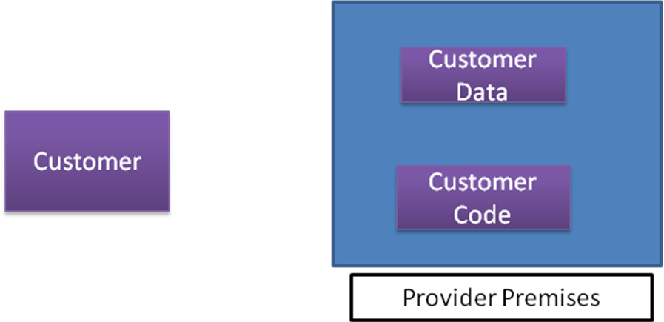

Data centre Security?

- Professional Security staff utilizing video surveillance, state of the art intrusion detection systems, and other electronic means.
- When an employee no longer has a business need to access datacenter his privileges to access datacenter should be immediately revoked.
- All physical and electronic access to data centers by employees should be logged and audited routinely.
- Audit tools so that users can easily determine how their data is stored, protected, used, and verify policy enforcement.

Data Location:
- When user uses the cloud, user probably won't know exactly where your data is hosted, what country it will be stored in?
- Data should be stored and processed only in specific jurisdictions as define by user.
- Provider should also make a contractual commitment to obey local privacy requirements on behalf of their customers,
- Data-centered policies that are generated when a user provides personal or sensitive information, that travels with that information throughout its lifetime to ensure that the information is used only in accordance with the policy

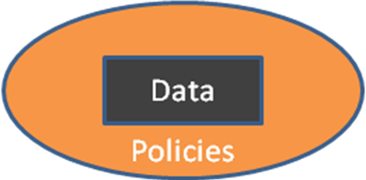

Backups of Data :

- Data store in database of provider should be redundantly store in multiple physical location.
- Data that is generated during running of program on instances is all customer data and therefore provider should not perform backups.
- Control of Administrator on Databases.

Data Sanitization:

- Sanitization is the process of removing sensitive information from a storage device.
- What happens to data stored in a cloud computing environment once it has passed its user’s “use by date”
- What data sanitization practices does the cloud computing service provider propose to implement for redundant and retiring data storage devices as and when these devices are retired or taken out of service.

Network Security:

- Denial of Service: where servers and networks are brought down by a huge amount of network traffic and users are denied the access to a certain Internet based service.
- Like DNS Hacking, Routing Table “Poisoning”, XDoS attacks
- QoS Violation : through congestion, delaying or dropping packets, or through resource hacking.
- Man in the Middle Attack: To overcome it always use SSL
- IP Spoofing: Spoofing is the creation of TCP/IP packets using somebody else's IP address.
- Solution: Infrastructure will not permit an instance to send traffic with a source IP or MAC address other than its own.

How secure is encryption Scheme:

- Is it possible for all of my data to be fully encrypted?
- What algorithms are used?
- Who holds, maintains and issues the keys?
Problem:
- Encryption accidents can make data totally unusable.
- Encryption can complicate availability Solution
- The cloud provider should provide evidence that encryption schemes were designed and tested by experienced specialists.

Information Security:

- Security related to the information exchanged between different hosts or between hosts and users.
- This issues pertaining to secure communication, authentication, and issues concerning single sign on and delegation.
- Secure communication issues include those security concerns that arise during the communication between two entities.
- These include confidentiality and integrity issues. Confidentiality indicates that all data sent by users should be accessible to only “legitimate” receivers, and integrity indicates that all data received should only be sent/modified by “legitimate” senders.
- Solution: public key encryption, X.509 certificates, and the Secure Sockets Layer (SSL) enables secure authentication and communication over computer networks.

